**Year 7 Science 2023**

**Physics 1 Test Name: \_\_\_\_\_\_\_\_**

**SECTION 1: MULTIPLE CHOICE** (1 mark each)

Circle your answers in the section on page 3.

1. Which of these is **not** a type of force?
   1. Push
   2. Pull
   3. Twist

d) Heat

1. Which is **true** about magnets and the way their forces act?
   1. Magnets can act over a distance or in contact with an object.
   2. Magnets can only act over a distance.
   3. Magnets can only act in contact with an object.
   4. Magnets can not act over a distance or in contact with an object.
2. Which of the diagrams below shows a correct **alignment** of magnets?

|  |  |
| --- | --- |
| a) | b) |
| c) | d) |

1. **Friction** is a type of
   1. force.
   2. weight.
   3. energy.
   4. gravity.
2. How do simple machines give a **mechanical advantage** when lifting an object?
   1. They allow less work to be done, but over a greater distance.
   2. They allow less energy to be used over a smaller distance.
   3. They allow less force to be used, but over a greater distance.
   4. They allow the same force to be used over a smaller distance.
3. Screws, ramps and stairs are all **examples** of
   1. levers.
   2. incline planes.
   3. wheels and axles.
   4. pulleys.
4. Which of these is an **example** of a wheel and axle?
   1. Scissors
   2. See-saws
   3. Jack
   4. Door knob
5. The diagram below shows different pulley arrangements.

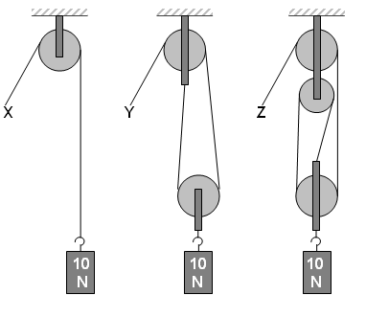

Which of the following statements is **correct** about the above diagram?

1. Force X, Y and Z are all equal.
2. Force X would be equal to 10N.
3. Force Y would be equal to 10N
4. Force Z would be equal to 30N
5. Study the chart below:

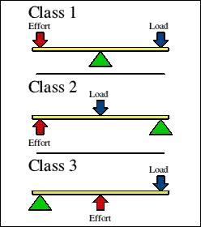

Which of the following diagrams shows a **Class 2 Lever**?

|  |  |  |  |
| --- | --- | --- | --- |
| a) | b) | c) | d) |

1. A **wheel and axle** is a special type of
2. incline plane
3. lever
4. pulley
5. gear

**Name \_\_\_\_\_\_\_\_\_\_\_\_\_\_\_\_\_\_\_\_\_\_\_\_**

**Year 7 Forces topic**

**Multiple choice answer section. Multiple Choice /10**

Circle your choice: **Short Answer /25**

**Total Mark /35**

1. **A B C D**
2. **A B C D**
3. **A B C D**
4. **A B C D**
5. **A B C D**
6. **A B C D**
7. **A B C D**
8. **A B C D**
9. **A B C D**

**10. A B C D**

**SECTION 2: WRITTEN**

**Write your answer in the spaces provided**

1. **Classify** each of these forces as **contact or non-contact** (4)

*(write n or c for each on your answer sheet)*

1. Magnetic \_\_\_\_\_\_\_\_\_\_
2. Friction \_\_\_\_\_\_\_\_\_
3. Gravity \_\_\_\_\_\_\_\_
4. Collision \_\_\_\_\_\_\_\_\_
5. What is the **reading** on each of the **spring balances** shown below? (4)

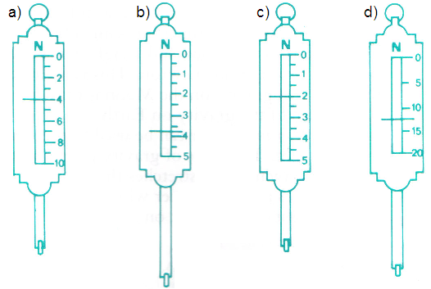

\_\_\_\_\_\_\_\_\_\_\_ \_\_\_\_\_\_\_\_\_\_\_ \_\_\_\_\_\_\_\_\_\_\_\_ \_\_\_\_\_\_\_\_\_\_\_\_

1. Explain why levers, inclined planes, gears, wheels and axles are called “**machines**”. (1)

\_\_\_\_\_\_\_\_\_\_\_\_\_\_\_\_\_\_\_\_\_\_\_\_\_\_\_\_\_\_\_\_\_\_\_\_\_\_\_\_\_\_\_\_\_\_\_\_\_\_\_\_\_\_\_\_\_\_\_\_\_\_\_\_\_\_\_\_\_\_\_\_\_\_\_\_\_\_\_\_\_\_\_\_\_\_\_\_\_\_\_\_\_\_\_\_\_\_\_\_\_\_\_\_\_\_\_\_\_\_\_\_\_\_\_\_\_\_\_\_\_\_\_\_\_\_\_\_\_\_\_\_\_\_\_\_\_\_\_\_\_\_\_\_\_\_\_\_\_\_\_\_\_\_\_\_\_\_\_\_\_\_\_\_\_\_\_\_\_\_\_\_\_\_\_\_\_\_\_\_\_\_\_\_\_\_\_\_\_\_\_\_\_\_\_\_\_\_\_\_\_\_\_\_\_\_\_\_\_\_\_\_\_\_\_\_\_\_\_\_\_\_\_\_\_\_\_\_\_\_\_\_\_\_\_\_\_\_\_\_\_\_\_\_\_\_\_\_\_\_\_\_\_\_\_\_\_\_\_\_\_\_\_\_\_\_\_\_\_\_\_\_\_\_\_\_\_\_\_\_\_\_\_\_\_\_\_\_\_\_\_\_\_\_\_

1. What **type** of simple machine is shown in each diagram? (4)

|  |  |  |
| --- | --- | --- |
| a)    \_\_\_\_\_\_\_\_\_\_\_\_\_\_\_\_\_\_\_\_\_ | c)  bd10065_  \_\_\_\_\_\_\_\_\_\_\_\_\_\_\_\_\_\_\_\_ |  |
| b)    \_\_\_\_\_\_\_\_\_\_\_\_\_\_\_\_\_\_\_\_\_ | d)    \_\_\_\_\_\_\_\_\_\_\_\_\_\_\_\_\_\_\_\_\_ |

1. Levers can be used to make lifting **easier** by producing a greater force (2)
2. How can you increase the force?

\_\_\_\_\_\_\_\_\_\_\_\_\_\_\_\_\_\_\_\_\_\_\_\_\_\_\_\_\_\_\_\_\_\_\_\_\_\_\_\_\_\_\_\_\_\_\_\_\_\_\_\_\_\_\_\_

\_\_\_\_\_\_\_\_\_\_\_\_\_\_\_\_\_\_\_\_\_\_\_\_\_\_\_\_\_\_\_\_\_\_\_\_\_\_\_\_\_\_\_\_\_\_\_\_\_\_\_\_\_\_\_\_

1. What must you do more of?

\_\_\_\_\_\_\_\_\_\_\_\_\_\_\_\_\_\_\_\_\_\_\_\_\_\_\_\_\_\_\_\_\_\_\_\_\_\_\_\_\_\_\_\_\_\_\_\_\_\_\_\_\_\_\_\_

\_\_\_\_\_\_\_\_\_\_\_\_\_\_\_\_\_\_\_\_\_\_\_\_\_\_\_\_\_\_\_\_\_\_\_\_\_\_\_\_\_\_\_\_\_\_\_\_\_\_\_\_\_\_\_\_

1. The three simple machines below are all types of levers.

Identify the fulcrum (f), effort (e), load (l) in each case. (6)

\

1. 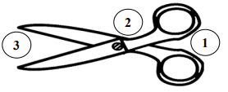\_\_\_\_\_\_\_\_\_\_\_\_\_\_\_\_\_\_
2. \_\_\_\_\_\_\_\_\_\_\_\_\_\_\_\_\_\_
3. \_\_\_\_\_\_\_\_\_\_\_\_\_\_\_\_\_\_

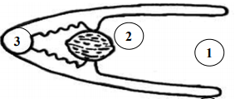

1. \_\_\_\_\_\_\_\_\_\_\_\_\_\_\_\_\_\_
2. \_\_\_\_\_\_\_\_\_\_\_\_\_\_\_\_\_\_
3. \_\_\_\_\_\_\_\_\_\_\_\_\_\_\_\_\_\_

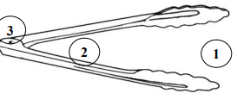

1. \_\_\_\_\_\_\_\_\_\_\_\_\_\_\_\_\_\_
2. \_\_\_\_\_\_\_\_\_\_\_\_\_\_\_\_\_\_
3. \_\_\_\_\_\_\_\_\_\_\_\_\_\_\_\_\_\_
4. Determine whether the object forces are balanced or unbalanced by circling one. (4)

a) Balanced / Unbalanced  
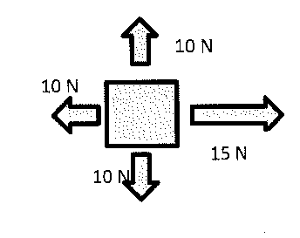

b) Balanced / Unbalanced  
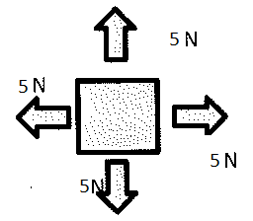

1. Balanced / Unbalanced

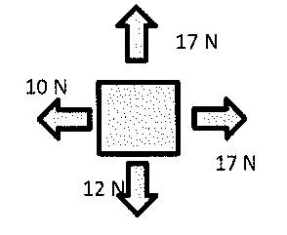

d) Balanced / Unbalanced  
  
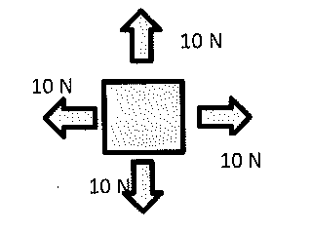

**END OF TEST (OUT OF 35 MARKS)**